Mechanical Systems Dynamics

**Fundamentals of experimental**

**modal analysis**

Enrico Gussoni - 884089

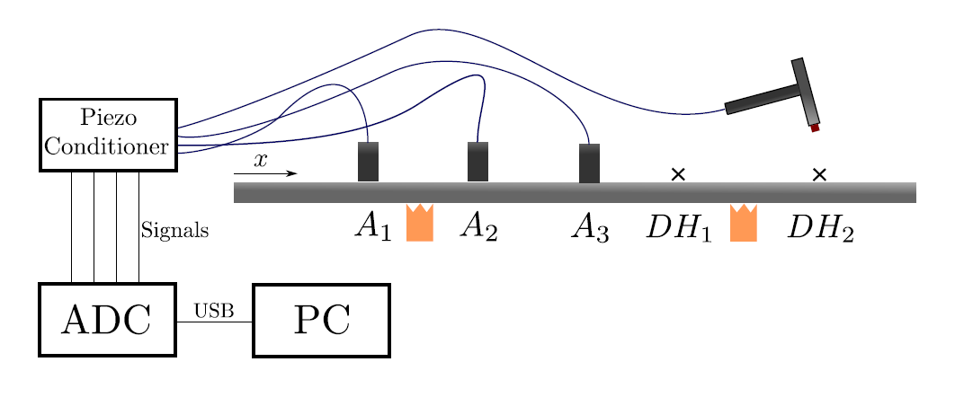

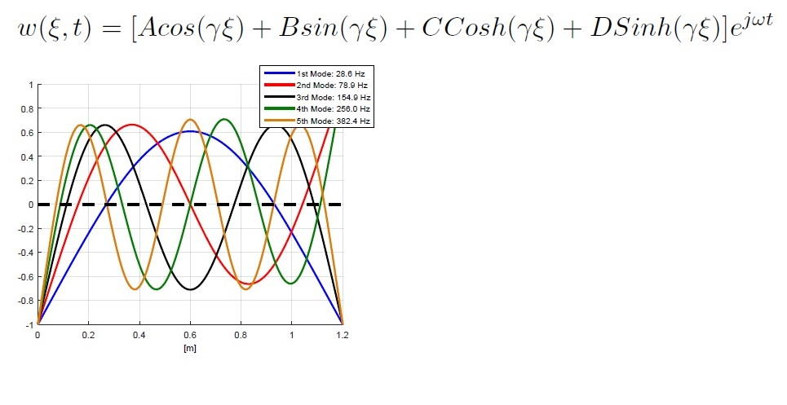To analyze this free-free beam (the supports sustain the beam but let it free to move), and compare the results with the analytical (fig.1), tree accelerometers have been displaced in position A1, A2 and A3, while a shock is performed trough a dynamometrical hammer in DH1 And DH2. A control on the reciprocity is subsequently performed inverting DH1 with A1.

First of all we analyze the frequency response function obtained by the tree accelerometers with a resolution of 0.02 Hz. (Table 1)

In the amplitude/frequency diagram it is possible to see a clear correspondence between all the accelerometers while in the phase/frequency this is not so clear, mostly because of noise in the part of the spectrum in which the modulus is close to 0 and so numerical errors occur in the computation and the phase in this zone is random.

Fig. 1

Looking at the peaks of the frf it is possible to evaluate the natural frequencies of the system (in practice that can be easily done in Matlab trough the command “*findpeaks*”) using the superposition of the tree frf for a better approximation. The result (in Hz) is:

F1 = 28,7; F2 = 80,22; F3 = 155,8; F4 = 256,6; F5 = 381,3:

|  |
| --- |
|  |
|  |
|  |

**Tab.1**

In the natural frequencies, by definition, the internal damping of the system is not considered. It could be anyway evaluated trough the frf itself through 1) the Half-Power points method and 2) the Slope of the phase method.

1. *This method can be used in vibrating systems with several d.o.f. where the natural frequencies are sufficiently differentiated and damping is sufficiently low, so that, under resonance conditions the predominant contribution to the response of the actual system is mainly due to the resonant mode, making it behave like a 1 d.o.f.system. It can be shown that the non-dimensional damping h is linked to the pulsations ω1 and ω 2 and to the natural pulsation of the system ω 0.*

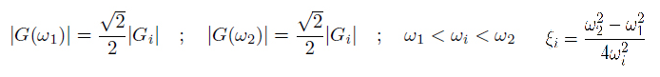

Results are: ξ1 ξ2 ξ3 ξ4 ξ5

ξ1 ξ2 ξ3 ξ4 ξ5